**Research4Life Impact Report: Changing the face of global research**

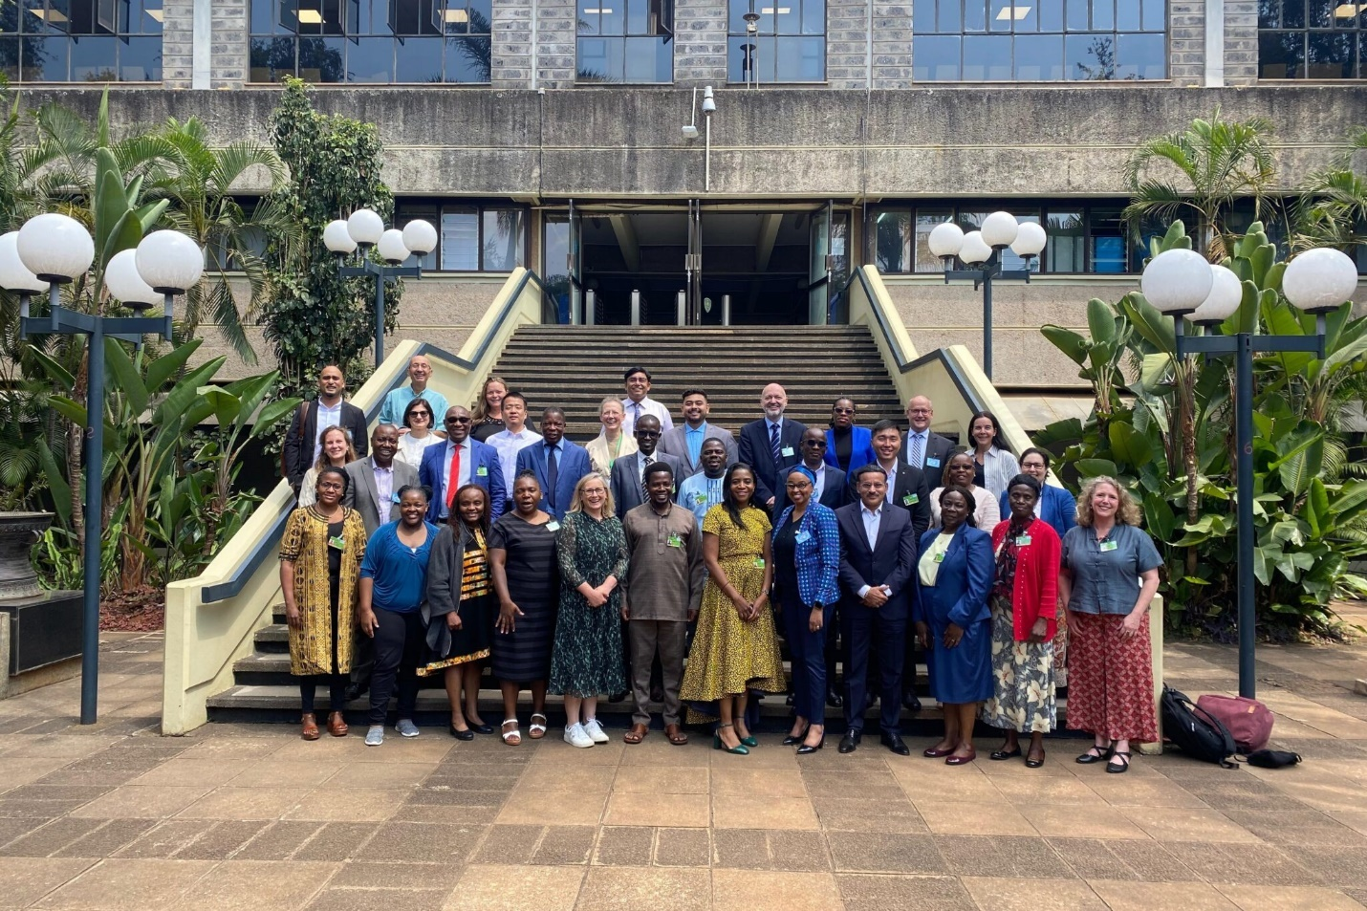

Members of Research4Life at the General Partners Meeting held in Nairobi, Kenya, July 2024.

**Research4Life spikes research output by up to 75%**

For over twenty years, Research4Life has been helping individuals in educational, research, and policy institutions in 125 lower income countries to participate fully in the global scientific and research community. Low- and middle-income countries

(LMICs), home to 85% of the world’s population, but just 0.2% of researchers, have been largely excluded from this participation.

Our mission at Research4Life is to build an inclusive, diverse, and equitable scholarly communications environment by delivering free or low-cost online access to academic and professional peer-reviewed content, user-focused training, and relevant resources to researchers in lower income countries. Access to a wide pool of trusted, evidence-based, research information is essential for well-informed and up-to-date research and teaching materials.

Research4Life provides crucial access to over 230,000 research resources in over 11,500 institutions across academic, research, industry (such as healthcare and agriculture), NGOs and government, as well as comprehensive knowledge bridging training for research design, discovery, and communications. Research4Life is the collective name for the five programs – Hinari, AGORA, OARE, ARDI and GOALI – designed to enhance the scholarship, teaching, research, practice and policy making of the many thousands of researchers, faculty, scientists, and professional specialists in lower income countries.

We are proud to say that our efforts have truly made a significant difference in people’s lives. According to 2024 data from a WIPO study, access to research through Research4Life spikes research output by up to 75% in LMICs.

Click for a link to a map of Research4Life eligible countries: <https://www.research4life.org/access/eligibility/>

Click to read more about the Research4Life programs: https://www.research4life.org/about/programs/

**Making change would not have been possible without the help of our many partners. Thanks to:**

Two hundred international publisher partners, and the International Association of Scientific, Technical & Medical Publishers (STM)

Program Managers: FAO (Food and Agriculture Organization of the United Nations), ILO (International Labour Organization), UNEP (United Nations Environment Programme), WHO (World Health Organization) and WIPO (World Intellectual Property Organization)

University partners: Cornell and Yale Universities

Training, Service and Technical partners: Information Training and Outreach Center for Africa (ITOCA), Clarivate (Serials Solutions), PortSys and US National Library of Medicine

Our user community: Members of the User Group, champions, advocates, and formal

or informal Connectors and ambassadors raising users’ voices within Research4Life and beyond.

**Welcome from our Executive Council**

LMICs are home to eighty-five percent of the world’s population, but make up approximately 0.2% of its researchers.

We are proud to say that, indeed, this document can live up to the title of “Impact” report. New research has shown us that the access that Research4Life provides has spiked research output by up to 75%. But we aren’t stopping now. Since our inception twenty years ago, we’ve done some evolving, and have revisited our mission statement.

Our mission today is to “foster inclusivity, diversity, and equity in scholarly communication.” This means we continue to be committed to creating a diverse and equitable scholarly environment where all researchers can thrive: bridging the gap, providing vital online access to peer-reviewed academic and professional content for institutions in lower-income countries.

We do this in order to empower researchers to conduct ground-breaking research, enhance teaching, and inform policy making in crucial areas like health, agriculture, and environmental sciences, to address global challenges.

We are contributing to the UN Decade of Action for accelerating the Sustainable Development Goals by increasing research participation from LMICs.

We know that equity in research is crucial to solving global challenges. Evidence-based policymaking must be developed from research that is both tailored to specific context and has an understanding of local issues. By 2030, we aim to have significantly increased the participation of researchers as both consumers and producers of critical research, providing the necessary capacity building and strengthening through local networks and partnerships.

We are transitioning Research4Life from content donation to fostering reciprocal engagement,

in order to nurture rich and diverse scholarly exchange. We have made it our mission to increase representation and participation of researchers from LMICs in the research landscape. Research that addresses global challenges

and also meets the needs of local and regional communities is crucial. Our aim is to significantly elevate voices and the presence of researchers from lower-income countries to the forefront of global research dialogue.

Real strides have been made and we look forward in the coming years to continuing the work our predecessors have started. Thank you to all those who have volunteered to help, and as you are reading this, we hope you are inspired to join us, as we work diligently to empower the world’s problem solvers and “movers and shakers.”

Click to read more about our Research4Life Executive Council Chair Lise McLeod and Vice-Chair Tandi Lwoga: <https://www.research4life.org/news/welcome-new-exco-chair-and-vice-chair/>

**Research4Life in Numbers**

Research4Life spikes research output by [up to 75%](https://www.research4life.org/press-releases/wipo-study-research4life-program-spikes-research-output-75-percent-low-middle-income-countries/) in low- and middle-income countries.

*11,500 Institutions Registered With R4L’s Portal; 232,000 Resources Available; 125 Low- Middle- Income Countries; 41,000 Journals; 205,000 Books; 160 Databases*

***After Joining R4L***

*75% Increase Health Science Publishing; 20% Increase In Clinical Trials Uptake;*

*Between 2021 and 2023, we had almost 6 million portal page views;*

Academic paper output increased by 80–100%. (disclaimer: in the Caribbean, Central Asia, Europe and Latin America)

Clinical trial activity rose by up to 35% (disclaimer: East Asia, the Pacific, the Middle East and North Africa)

***Contributing to the expansion of the pipeline of research from LMICs***

*From the research we provide via our publisher partners, to our work with Information Training & Outreach Centre for Africa (ITOCA), we are successfully contributing to the expansion of the pipeline of research from LMICs. We are continually examining our approach and measuring our successes and failures. The key findings of our user review confirmed that Research4Life is a relevant resource for users who are aware, and have had appropriate training, and supporting infrastructure to use the resource. For these individuals, the loss of Research4Life would leave a significant gap.*

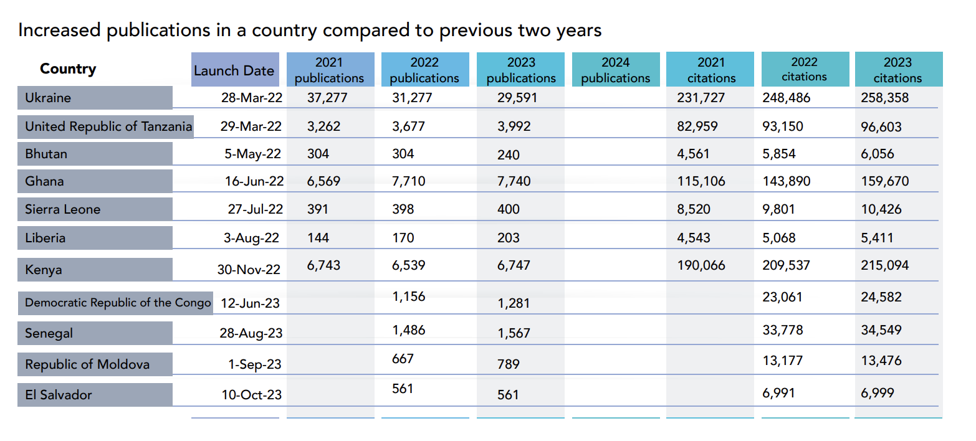

**Research4Life offers a number of targeted initiatives for users to make the best use of the Partnership:**

Author and Librarian Hubs: Free training materials for librarians, information specialists, scientists, researchers and students to improve professional skills.

Massive Open Online Course (MOOC): MOOCs help users get the most out of Research4Life. To date, nearly 7000 users have been trained.

Virtual Master Trainer Course: To enhance training skills, 250 users have completed this course after undertaking the MOOC.

Research4Life webinars: Specially developed webinars covering best practices for using Research4Life, as well as improving research skills.

Partners resources: Free resources for librarians and researchers, toolkits and learning programs.

Institution support: A helpdesk that ensures institutional access, resolves reports of content unavailability, and provides regular information about the content and services available.

Publisher Training: The modules covered: DOAJ indexing criteria, principles of transparency, good practices in scientific communication, predatory practices and use of AI in scholarly publishing

In 2024 we embarked on an authentication expansion project with Ubuntunet Alliance for Research and Education Networking, an alliance of Eastern and South African National Research and Education Networks (NRENs) supporting a vibrant connected research and education community. This project piggybacks federated identity access for large institutions to allow Research4Life to recognize their users via institutional sign in.

Bhutan Health Journal: now Indexed following training

**Empowering local researchers in their communities**

The impact for our users goes beyond academic reach, by empowering local researchers in their communities, whether they work in a clinic or an industrial farm. Alexander Cuntz, Head of Creative Economy Sector, WIPO, and Alessio Muscarnera, Research Fellow, Department for Economics and Data Analytics, WIPO recently summed up the importance of Research4Life’s impact in medicine: “Researchers tend to target diseases that affect the local population and may be overlooked by researchers abroad. Enabling such access may help innovation in neglected diseases, mainly by connecting local teams to the global knowledge base. Aside from increased scientific activity, Research4Life also reports direct effects from Hinari regarding medical practice and patient care.”

Dr. Nguyen Duc Chinh from Viet Duc Hospital, Hanoi, Viet Nam, relied heavily on Research4Life for his PhD on intestinal tuberculosis (TB) and surgical treatment. TB is prevalent in Viet Nam, but there is a relative lack of information on intestinal TB. He notes that, “With the information and knowledge we obtain, we feel more confident in practicing and implementing respected medical expertise from around the world.’ In short, as Dr. Chinh emphasizes: ‘Good research leads to better patient care.”

Muscarnera and Cuntz also highlight how connecting researchers can avoid unnecessary duplication of efforts: “Dr. Sami Hyacinthe Kambire at Kamboinsé Research Station, Ouagadougou, Burkina Faso, (also) found his research progressing faster and wrote grant winning funding proposals thanks to Hinari. Before his institution adopted Research4Life, Dr. Kambire often devoted considerable time to research already performed elsewhere. The initiative helped reduce these duplicative research efforts in global health sciences and increase the quality of local teaching and education.”

**Overcoming roadblocks for researchers in LMICs**

Researchers, policy-makers, practitioners, students, and teachers working in low resource countries have historically suffered from a lack of access to up-to-date research essential for furthering studies, discovering evidence, sharing findings, teaching, practicing, and developing public policy.

We have also learned about many of the additional roadblocks researchers face in trying to access the content we provide. Challenges range from staff turnover and shortages to connectivity issues

at libraries, and unreliable internet connections, meaning institutions have access but cannot utilize it. As we learn about these issues, we have begun to see them as an important part of the equation for equity and access and are working to do our part where we can. Our aim is to increase logins from registered users when and where possible over the coming years.

To meet these challenges head on, in 2022 the innovative Country Connectors program was launched.

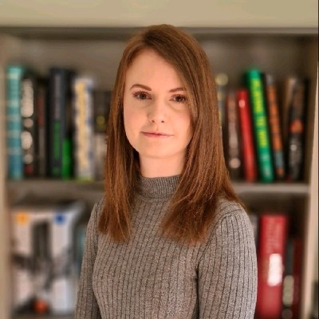

Catherine Hodgson, Sustainability Manager, Taylor & Francis:

“Our long standing partnership with Research4Life is an important part of encouraging equitable participation in knowledge generation.

It is really encouraging to see that removing financial barriers to accessing research can result in greater knowledge sharing and real-world impact. ”

Recent data from one of our publisher partners Taylor & Francis, shows that published work has also had practical influence on policy. Using Dimensions Explorer, their data analysts looked at the number of articles published by authors from Research4Life countries where they have cited content from Taylor & Francis subscription journals.

Over 4,500 journal articles from these authors cited Taylor & Francis subscription-based content and out of these 4,500+ articles, 1,578 received ‘Altimetric attention’. Among the articles with Altimetric attention, 52 were cited in policy documents. This indicates that these articles had an impact on policy making or were influential enough to be referenced in formal policy discussions.”



**Ylann Schemm, Executive Director, Elsevier Foundation**

“Country Connectors represents a real ground shift for Research4Life.

The program offers critical support for national and regional champions many of whom are librarians, researchers and doctors, to build centers of research excellence from Tanzania

to Honduras and Bhutan. For the Elsevier Foundation, it’s been a natural progression to become early adopters and core supporters of Country Connectors – building on 15 years of more traditional training grants – to embrace Research4Life’s new strategy of supporting LMIC researchers as both users and producers of knowledge. Needless to say, we’re proud to make Elsevier’s content available through Research4Life, but even prouder to support Country Connectors’ powerful outreach together with a growing community of partners!”

**Country Connectors: Bridging the gap**

List of Country Connector Countries as of November 2024:

1. Bhutan
2. Republic of Tanzania
3. Liberia
4. Ghana
5. Kenya
6. Senegal
7. Sierra Leone
8. El Salvador
9. Democratic Republic of Congo
10. Republic of Moldova
11. Ukraine
12. Kyrgyzstan
13. Angola
14. Uganda
15. Honduras* (star indicates this country is pending sign-up)

Our Country Connectors network project was established in 2022 to deliver local interventions to heighten awareness about Research4Life resources in eligible countries. The project focuses on strengthening the capacity of information use and management and building communities of evidence users within national and regional settings. This way we support user communities at local level by building local networks and partnerships.

Country Connector Goals include: Customization of research capacity needs; Engagement with local partners to boost research and implementation; Enquiries in local languages; Capacity building in local languages; Guidance for local publishers for inclusion in Research4Life; and Quick access for enquiries and one on one support.

As a global organization, often meeting and working virtually, with many volunteers from resource rich countries, it is important that we have equitable participation and representation throughout the partnership. Every voice needs to be heard, and Country Connectors helps to empower that philosophy both externally and internally.

**Case study: Promoting local publishing in Bhutan**

Research4Life activities in Bhutan saw significant developments in 2023, with active engagement by the Country Connector and ambassadors. A comprehensive list of local journal publishers was compiled, identifying 20 publishers, 16 of whom were active. Initial efforts to organize a meeting with publishers faced low registration, however the Country Connectors  engaged in committee meetings, recruited new ambassadors, and conducted productive follow-ups to enhance outreach.   
  
A highlight was the observance of World Evidence-Based Healthcare Day by Khesar Gyalpo University of Medical Sciences, where a Research4Life webinar was attended by 90 participants. Ambassadors and users participated in the Research4Life Virtual Master Trainer course and the Publishing and Research Communication short course, which spanned from October to November.  
  
The year concluded with a focus on local publishers, featuring a specialized course in collaboration with the Directory of Open Access Journals (DOAJ), aimed at strengthening local journal publications.   
  
In 2024, Country Connectors in Bhutan achieved a significant milestone with the Bhutan Health Journal being successfully indexed in the DOAJ increasing the visibility and global reach of Bhutan’s research. This achievement reflects the collaborative efforts of local publishers, academic institutions, and Research4Life to elevate scholarly publishing standards in the country.

**Deeper Impact Case Study:**

In 2024, we ran an accredited training program in collaboration with the Directory of Open Access Journals (DOAJ) and the Academy of Science of South Africa (ASSAf) tailored for local journal publishers. The program was offered in English, French, Spanish and Ukrainian and attracted 850+ attendees from 25+ countries across the globe.

**Case Study: A technology “first” for Research4Life in El Salvador**

El Salvador joined our Country Connectors program in 2023. The team, Celina Baires and Julio Cesar Bailon Salguero, has been applying highly innovative approaches to increase the reach and engagement of Research4Life in that country, so that librarians in institutions who utilize Research4Life can make sure the benefits are known to potential researchers. Earlier this year, the team developed a chatbot; this streamlined communication and directed users to a dedicated Research4Life page.

This handy tool for engagement has centralized interactions and facilitated direct communication with interested users, enhancing the overall efficiency of the Country Connector program in that nation.

**Case Study: Facing challenges head on in Liberia**

Liberia faces significant challenges such as limited internet penetration (only 30.1%) and a lack of developed infrastructure, especially road infrastructure, which makes local support crucial for continued outreach and development. In 2023, the Research4Life Country Connector for Liberia embarked on outreach activities to 11 education and health institutions in 3 of Liberia’s 15 political subdivisions. This was supported by a staff member from the WHO Country office. The 7-hour road trip to Margibi County enabled an understanding of some of the challenges and gaps experienced by the institutions.

Internet access is also a roadblock to access Research4Life material. While visiting several institutions that were registered with Research4Life, our Country Connector Stephen Browne found out first hand why several institutions had not signed in. At Cuttington Junior College, the Librarian informed the team that the lack of Internet connectivity and computers were the primary reasons for the low usage of Research4Life. Electricity was being rationed with the library allocated two hours of electricity a day. Hence the library at Cutting University had no Internet access when the Country Connector visited in 2023. There were more than 20 desktop computers in the lab, but they had not been used for more than a year. At Booker Washington Institute, the Library was unusable because it was being renovated – it had no roof. At the Central Agriculture Research Institute (CARI), which has some of the best agricultural researchers and extensionists in the country, there were no administrative staff onsite due to strike actions.

One of the projects our Country Connectors have embarked upon is to try and develop solutions for internet accessibility, by connecting libraries with partners who can provide them with internet access by connecting them with Wi-Fi hotspots and other community-based projects.

**Championing digital literacy in Burkina Faso**

**Image of Pascal Soubiega. He is wearing a blue suit, standing behind a podium with the words "United Nations".**

Pascal Soubeiga, an information research consultant, has been instrumental in enhancing digital and information literacy in Burkina Faso. Through Research4Life, Pascal has provided over 300 training courses on Research4Life, training more than 2,000 individuals, empowering students, researchers, doctors, and teachers with access to high-quality research and scientific information.

Focused Research4Life activities started in September 2008 in Burkina Faso: the first training session that Pascal attended was devoted to Agora, HINARI and OARE, and saw more than 50 participants, most of which were teachers. Building off this first one, the University of Ouagadougou, the University of Bobo Dioulasso and the University of Koudougou continued Research4Life trainings; these were followed by trainings from other institutions which included CREPA (Centre Regional pour l´Eau Potable), INERA (Institute of the Environment and Agricultural Research), ISTID (Institut des Sciences et Techniques de l’Information Documentaire), and the UN Technology Bank DAR (Digital Access to Research). It is with funding from DAR that Pascal started formal Research4Life trainings in Burkina Faso, Senegal and Madagascar.

Image of Kambou Kadio Kabou. She has short curly black hair and brown glasses. She is wearing a bright yellow blouse.

Kambou Kadio Kabou first encountered Research4Life at a 2008 workshop. Eager to share her new knowledge, she began a collaboration with the Information Training & Outreach Centre for Africa (ITOCA) to train her colleagues at the Centre régional pour l’eau potable et l’assainissement (CREPA). This led to her giving many more trainings to thousands of people virtually around the world.

Kabou also collaborates with higher training institutes and universities in Burkina Faso, including doctoral schools, training of doctoral students to search for scientific and technical information. Beyond this collaboration in the field of training, she has also implemented projects like TEEAL and DAR, launched local journals and facilitated the integration of courses on access to scientific information in certain education programs. To date, more than 20,000 individuals have been trained in Burkina Faso either in person or through MOOCs.

Kabou’s work has earned her the recognition of Knight of the Order of Academic Palms, a national order awarded to distinguished academics and teachers for their valuable services to universities, education and science, by the Ministry of Education Higher Education, Research and Innovation of Burkina Faso.

**Access to research is just the beginning**

**Research4Life has only reached a small fraction of its potential in terms of awareness, reach, usage and impact due to severe under-resourcing. While the Partnership has accomplished a tremendous amount through volunteer efforts and in-kind contributions, scaling-up remains challenging.**

Last year our expenditure was $421,975, while our total income was $413,898. Historically, the only source of regular income to cover the operating, outreach and training costs of Research4Life has been from Group B fees paid by institutions.

To respond to Research4Life’s unmet resource need, in 2020 we established Friends of Research4Life, a US-based 501(c)(3) charitable organization with an independent governance structure and Board of Directors. Friends of Research4Life aims to create more opportunities for Research4Life to expand our content collection, extend training programs and, vitally, to increase outreach and communications to reach a growing audience in our target countries.

|  |  |
| --- | --- |
|  | **2023 Results** |
| **Income $** |  |
| Group B fees | 237,874 |
| Friends of Research4Life | 176,024 |
| **Total Income** | **413,898** |
|  |  |
|  |  |
| **Expenditure $** |  |
| Country Connectors | 156,024 |
| Communications | 42,127 |
| Content Management | 8,000 |
| Technology | 113,045 |
| Capacity Development | 94,046 |
| Travel Expenses | 8,733 |
| **Total Expenditure** | **421,975** |
|  |  |
| **Net surplus/(deficit) $** | **-8,077** |

**Our goals**

Centricity of researcher lifecycle: Develop new services to increase publishing output and scholarly exchange

Content and the SDGs: Provide content that researchers need across all 17 SDGs areas

Continued usage: Increase usage of content and services

Seamless user journey: Guarantee state of the art technology to serve our communities

Equitable participation: Embed mechanisms for representation throughout the governance structure

High-performing structure: Ensure efficient and professionalized running of Research4Life

Sustainable funding: Evolve new funding streams and strengthen existing ones to create a modern fir for purpose organization

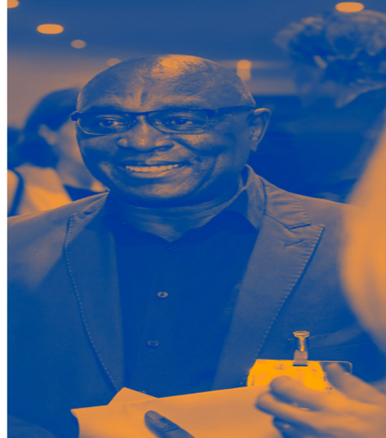

“Access to research is just the beginning… We’re implementing strategies to ensure researchers in countries like Bhutan, Tanzania and Ukraine are not only consuming research but also leading it – becoming authors, editors, and collaborators.” Gracian Chimwaza, CEO of ITOCA, Past Chair

Realizing opportunities for people and planet

Access to research, training, tools and professional information stimulates economic and social development. Friends of Research4Life aims to create more opportunities for Research4Life to expand its content, extend training programs and, vitally, to reach a growing audience in LMICs. Many hurdles remain in place for researchers in the low-resource countries and there is growing urgency to increase research participation from underrepresented researchers as both consumers and producers of knowledge – working towards the UN Sustainable Development Goals.

Back cover of report, has this quote:

“I have participated in initiatives like Research4Life that have emerged as beacons of hope with stakeholders … illuminating pathways toward equitable research practices. Through Research4Life’s innovative programs … libraries extend a lifeline to researchers in LMICs, empowering them with the tools and knowledge needed to drive positive change in their communities. By democratizing access to information, Research4Life, not only fosters a more inclusive research ecosystem but also amplifies the voices of researchers from underrepresented regions on the global stage.” Andrew Ojulong, University Librarian, Lira University, Uganda

**Join Us Today**

Your role is critical to the development of evidence-based policies and investment priorities. Friends of Research4Life offers our members, users and supporters of Research4Life the opportunity to contribute to the creation of a diverse and inclusive and equitable research ecosystem for all. Join us today.

Link to website: https://www.research4life.org/

Link to R4L LinkedIn: https://www.linkedin.com/company/research4life

Link to R4L Facebook: https://www.facebook.com/R4Lpartnership

Link to R4L X: https://x.com/r4lpartnership

Research4Life Logo